Supply Schneider Magelis XBT GT/GK/GTW HMI Parts
VICPAS HMI Parts Center supply Magelis XBT HMI part for replaced, include touch screen panel, protective film, membrane keypad and LCD Display. Please find the form below for Magelis XBTG/GC/GH/OT HMI model.

HMI Part No. | Size | HMI Part No. | Size
Schneider’s OPTI XBT OT Series Programmable Operator Interface modules |  | Magelis XBTG terminals series
XBTOT2110 | 5.7'' | XBTG2110 | 5.7''
XBTOT2210 | 5.7'' | XBTG2120 | 5.7''
XBTOT4320 | 7.5'' | XBTG2130 | 5.7''
XBTOT5220 | 10.4'' | XBTG2220 | 5.7''
XBTOT5320 | 10.4'' | XBTG2330 | 5.7''
Magelis XBT H advanced hand-held panel |  | XBTG4320 | 7.5''
 |  | XBTG4330 | 7.5''
XBTGH2460 | 5.7'' | XBTG5230 | 10.4''
Magelis XBT GC advanced touchscreen panel |  | XBTG5330 | 10.4''
 |  | XBTG6330 | 12.1''
XBTGC1100U | 3.8''
XBTGC1100T | 3.8''
XBTGC2000 | 5.7''
XBTGC2120U | 5.7''
XBTGC2120T | 5.7''
XBTGC2230U | 5.7''
XBTGC2230T | 5.7''
XBTGC2330U | 5.7''
XBTGC2330T | 5.7''

Product Description:
* Size 3.8~19 inch
General Size | 3.0" to 23″
Custom Size | 3.0″ to 24″
Fit in with | Panel display device
* Environmental ;
Temperature | Operating Range: -10°C ~ 60°C
 | Storage Range: -20° C ~ 70° C
Relative Humidity | Operating Range: 0%~90% RH (no dew falls)
 | Storage Range: 0% to 95% RH (no dew falls)
Altitude | Up to 3, 000m
* Electrical
Operation Voltage | Typical +DC 5V
Power Supply | USB or RS232
Interface | Full Duplex USB 2.0 (Full Speed) Plug and play compatible
 | Serial RS-232.
Current | 5mA~25mA
Electrostatic Endurance | No abnormal appearance after 10kv, 100Ω, 250PF electrostatic used
Isolation Resistance | > 20MΩ @ DC 25V
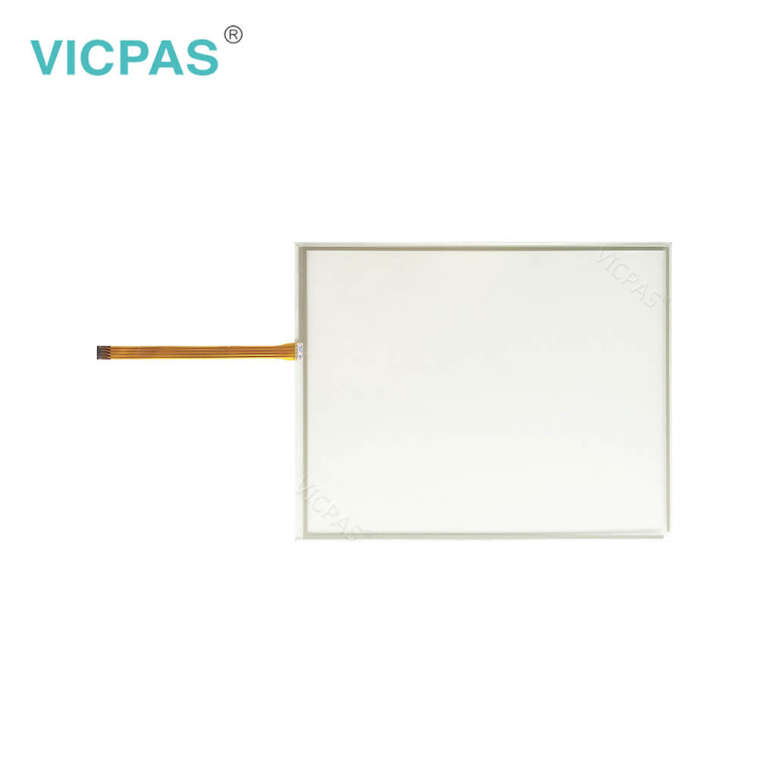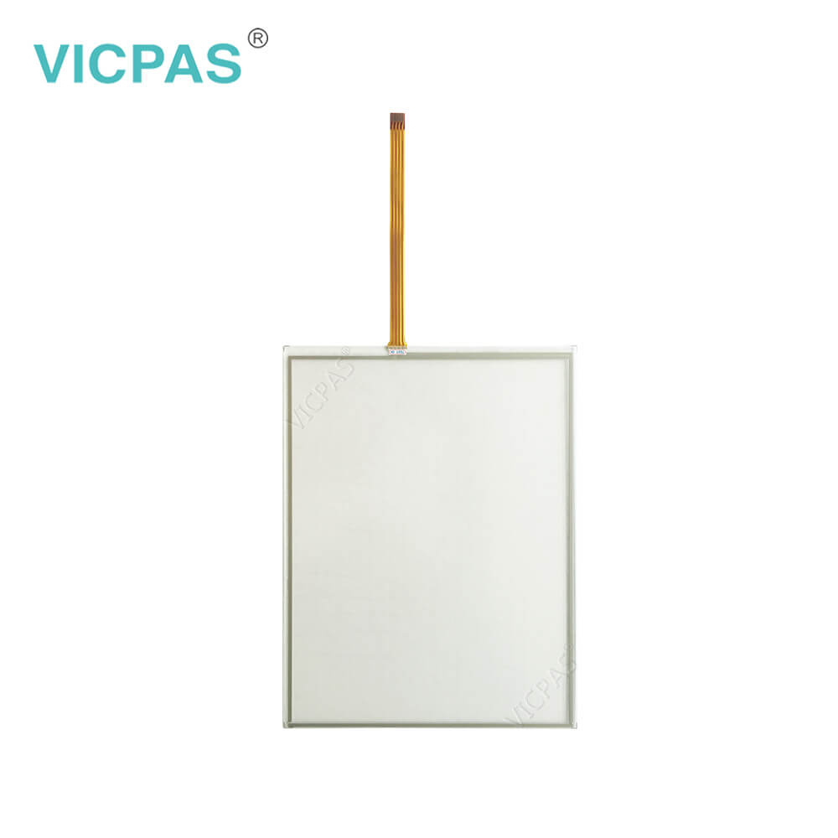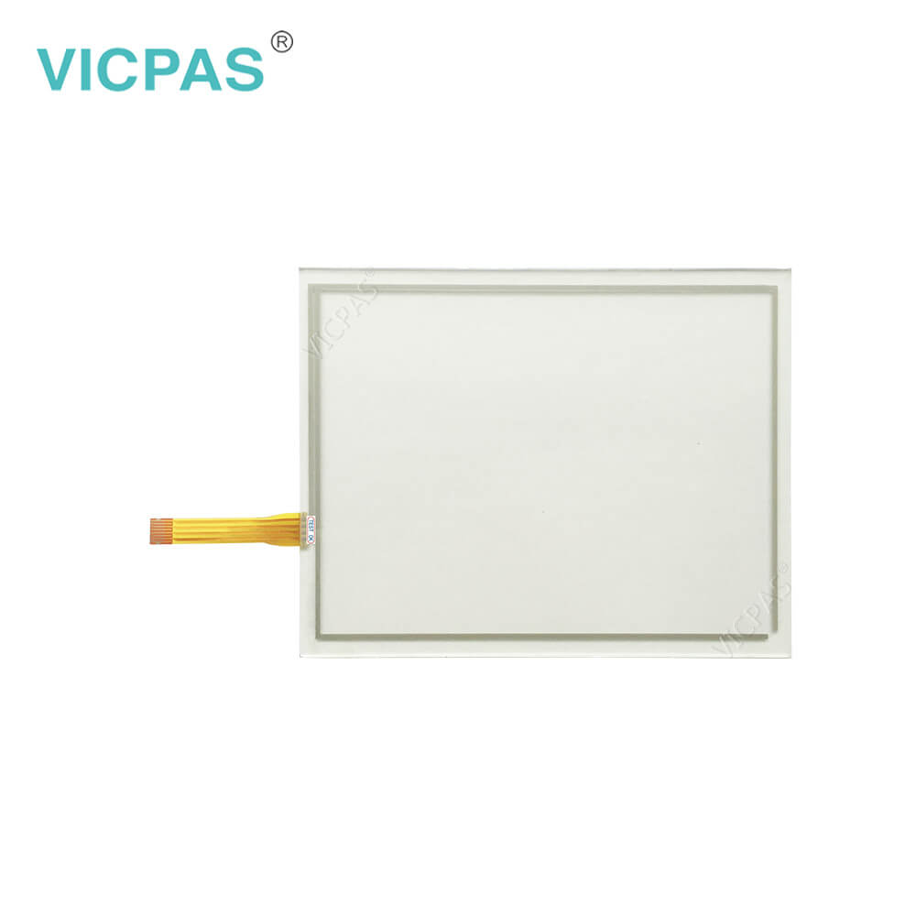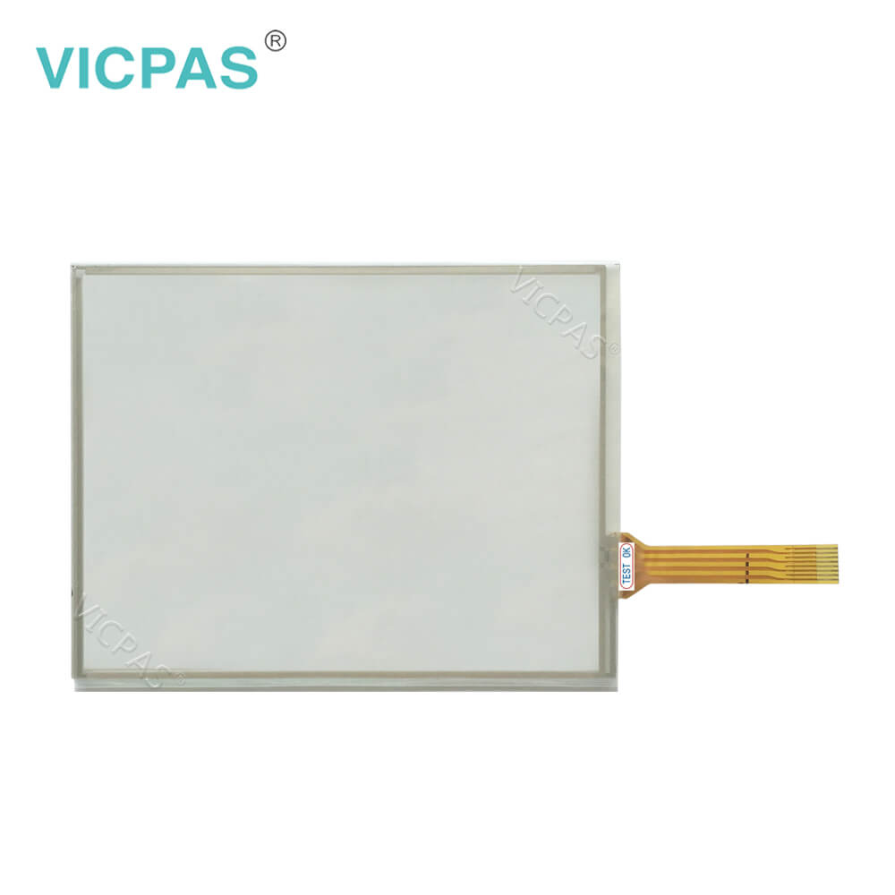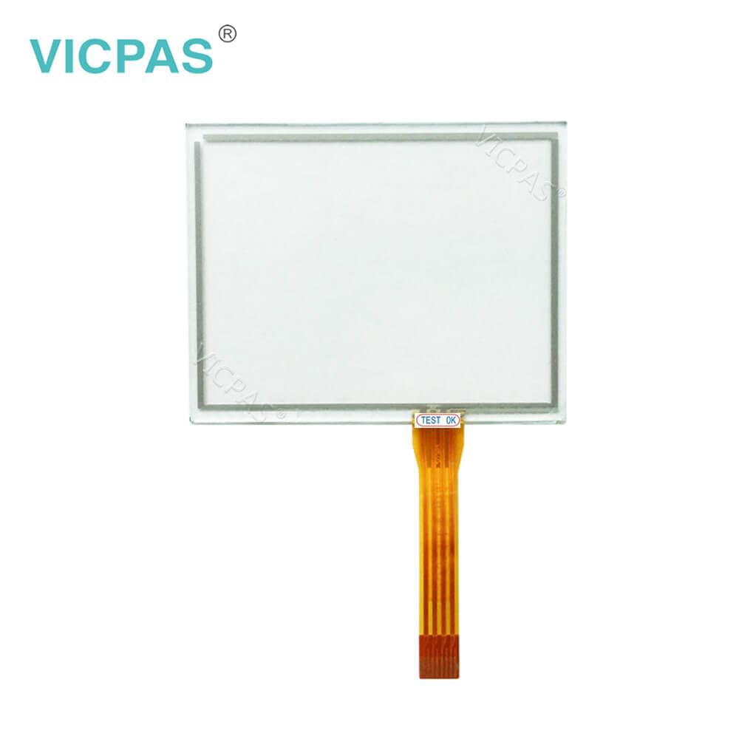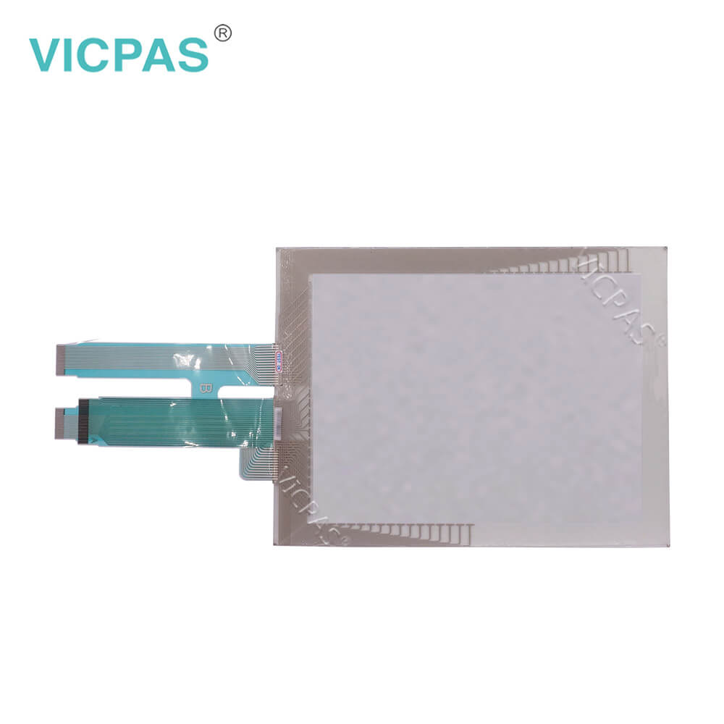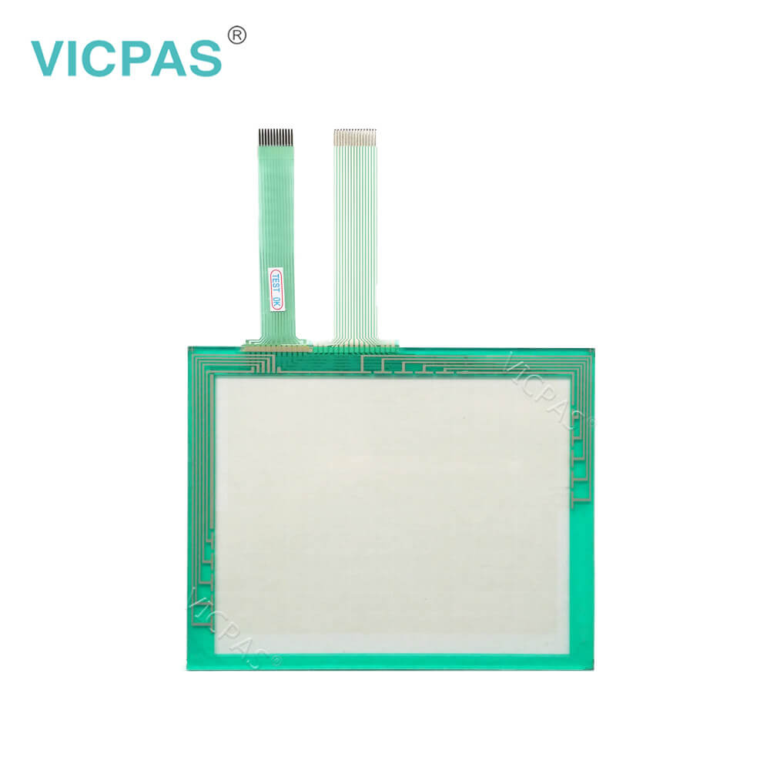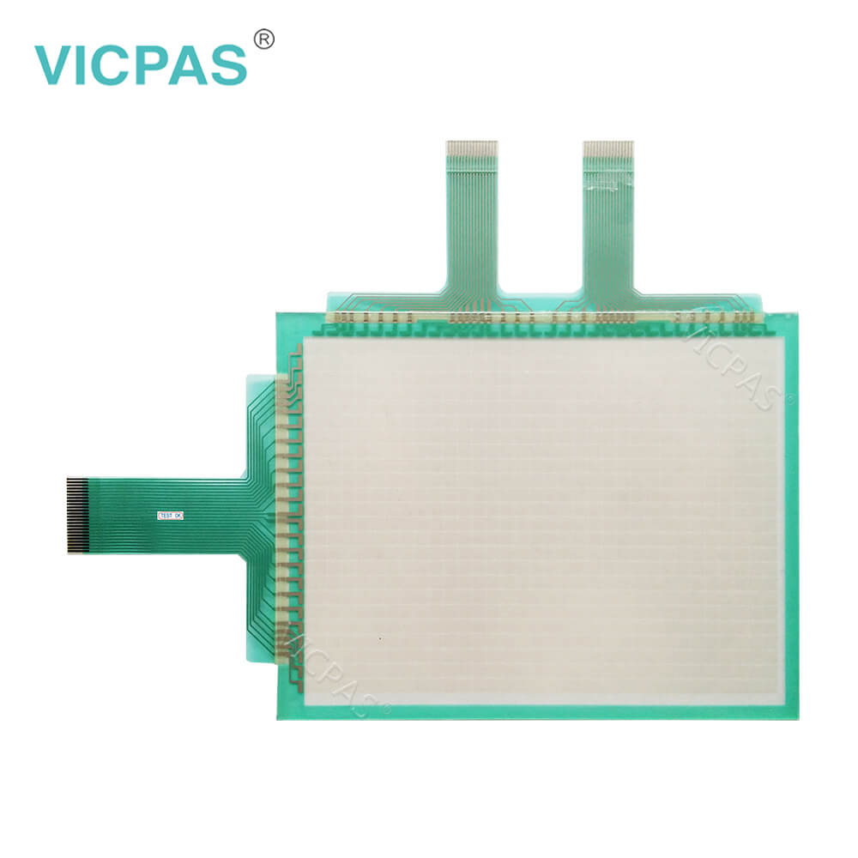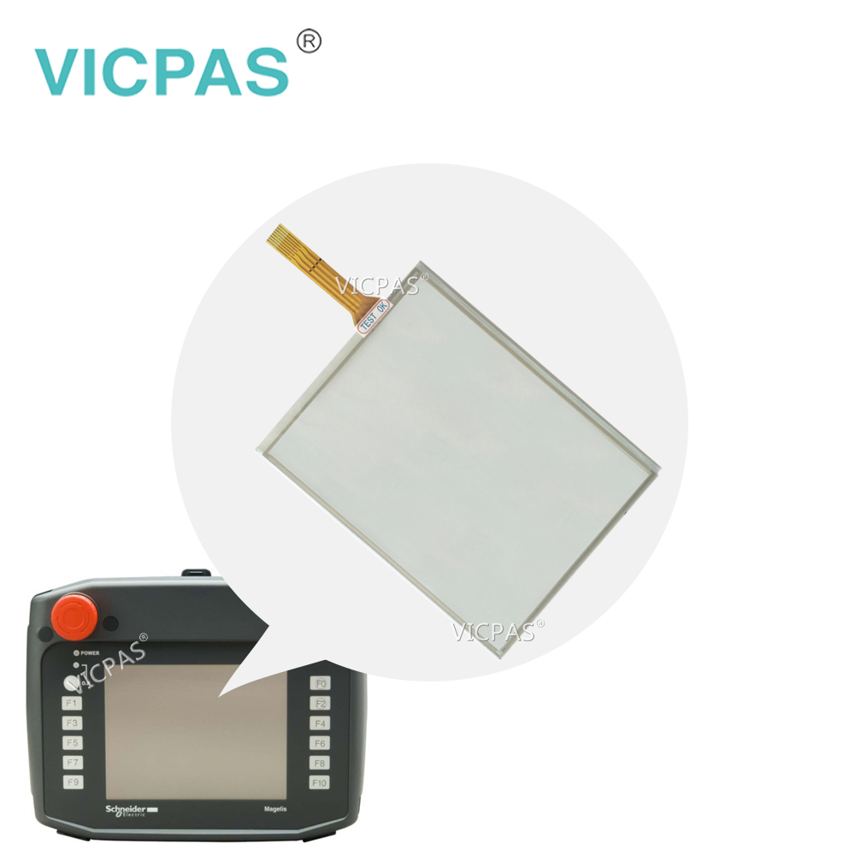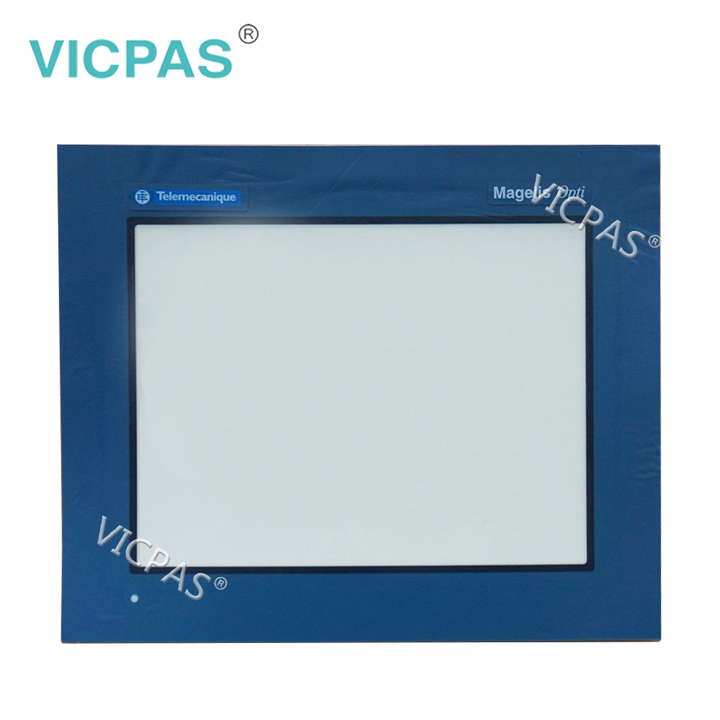
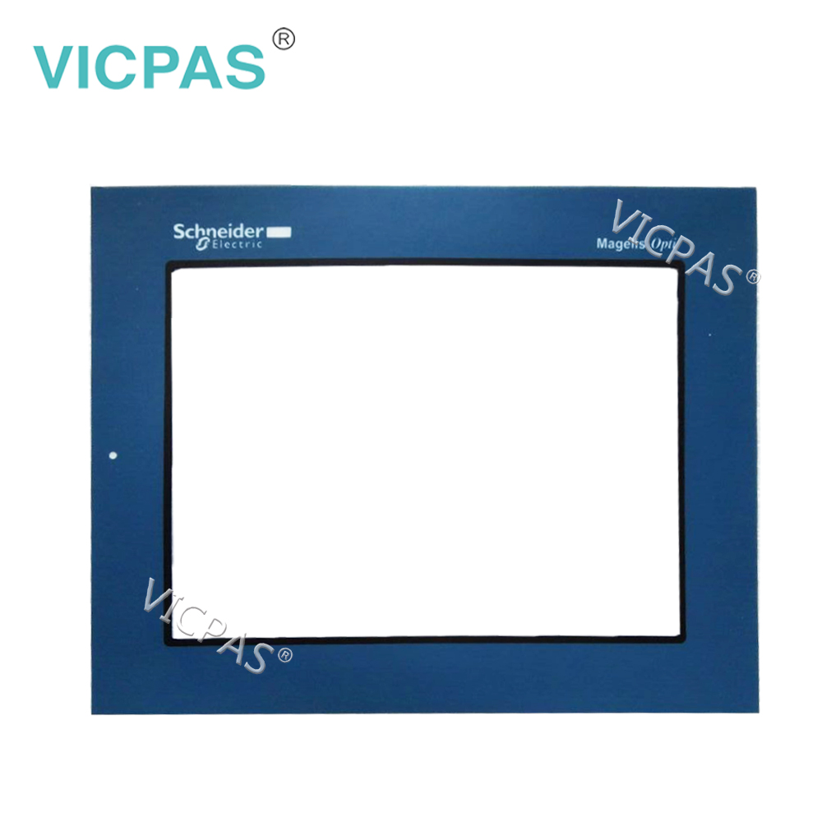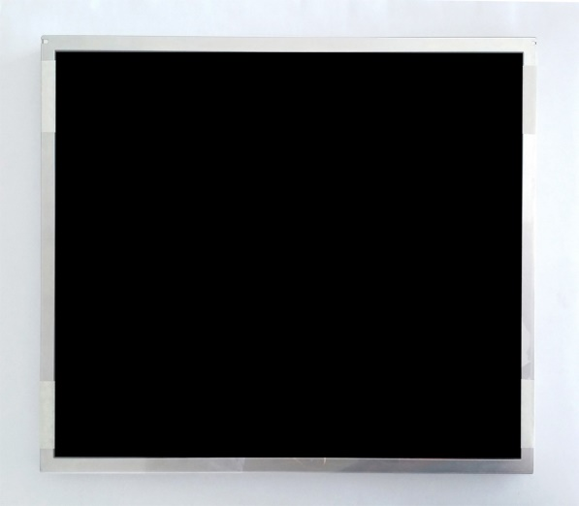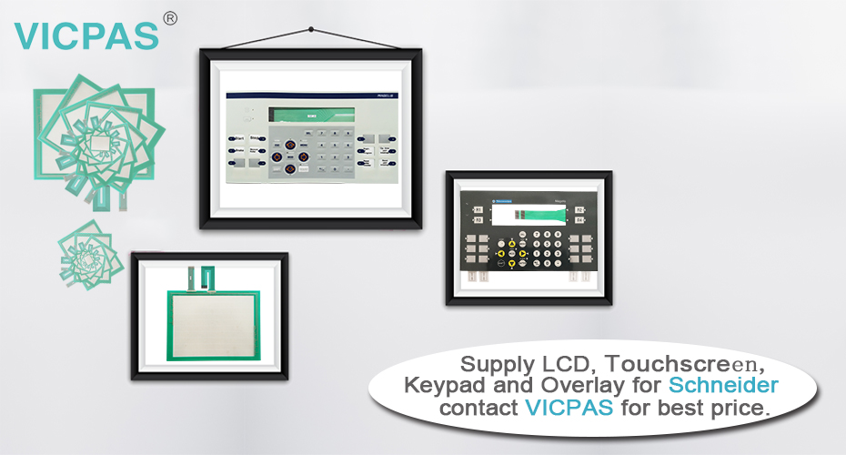

Condition:
All product are new, working in perfect condition,Meet bad environment,No need change any
shell and add any auxiliary to the HMI machine.

If you need more product detail, please contact us immediately. We will provide you with the best solution.
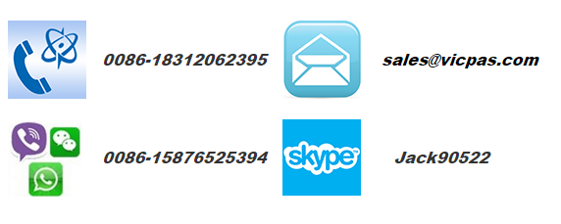

Company Profile:
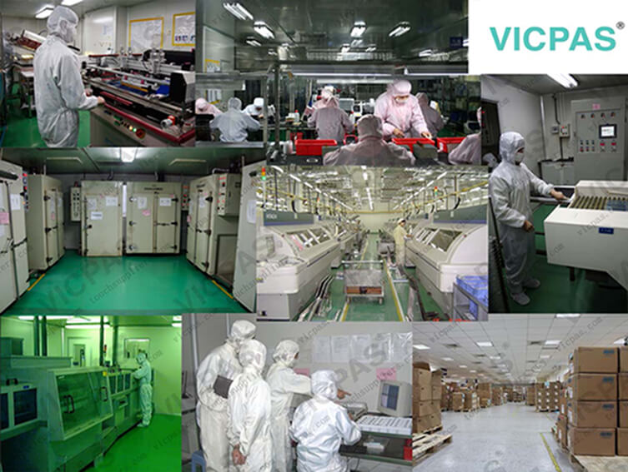

Guangzhou Vicpas Touch Technology Co.,Ltd using only the best materials and exacting standards of quality assurance, is committed to customer satisfaction in the Highest Quality Material, Large size, High light transmittance, Free of Maintaining, Complete Reliability, Superior Product Durability, Design Flexibility, World-Class Service and Support:
*The ITO film imported from Japan, with long life cycle-more than 1 million touches in one location without failure;
*Drift free, Deviation of Error below 1.5%, suitable for the operation;

Our Advantages:
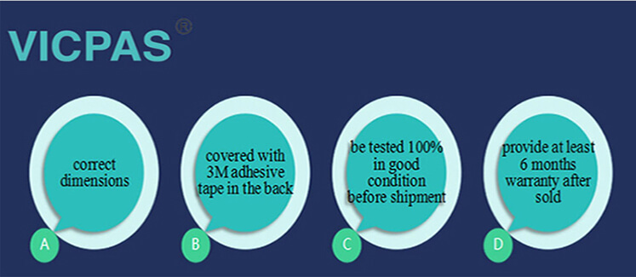
- Low cost
- Finger, gloved hand and stylus activation
- High accuracy and sensitivity
- High durability and reliability
- Contaminant proof and liquid resistance
- OEM is available.
To get more detail for OEM

Certifications:
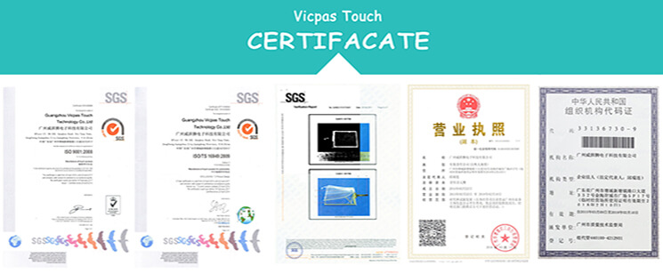

Packaging&Shopping:
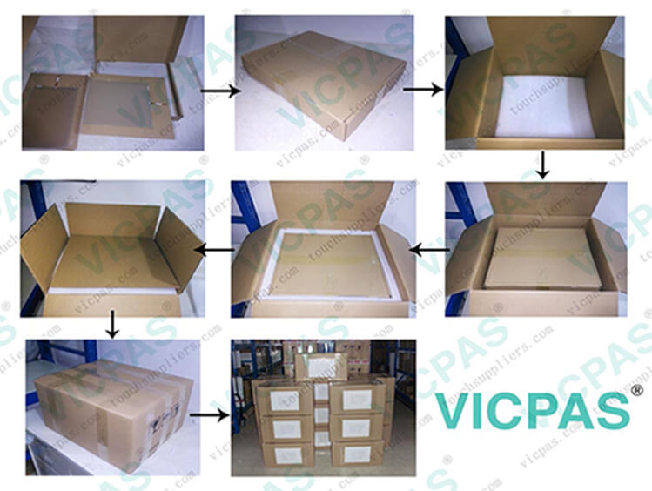
Packaging:
Outer packing is strong carton with Five corrugating medium, inner packing is foam which would protect the product in well condition.

Shipping:
We are shipping the goods to every country of the world!
Usually the goods will be sent at the next working day after payment, the shipping time depends on your country of residence, depending on your country's customs!
Our shipping method is Hong Kong DHL ,other shipping methods, such as Fedex is OK!
To get more detail for shipping
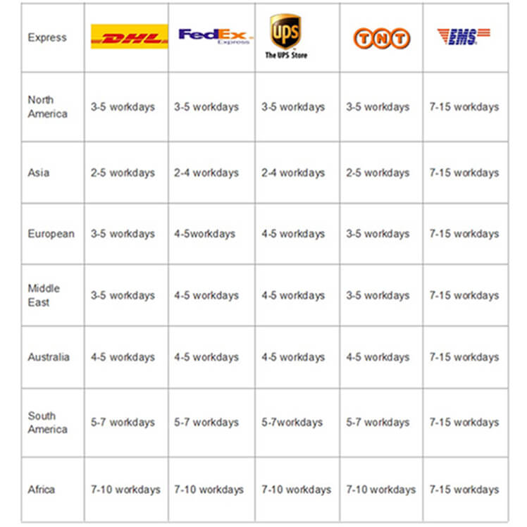

Our Services:
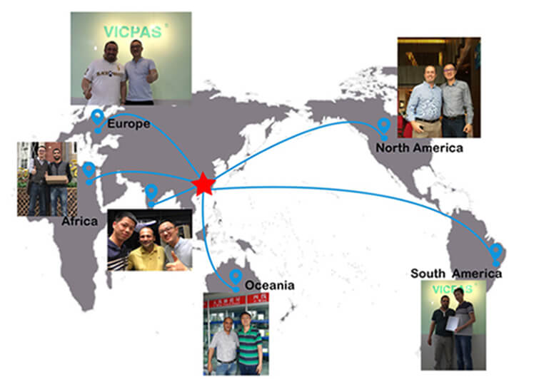
VICPAS has employed a variety of methods to improve the performance of the entire work force with a superior customer service strategy , aiming to provide excellent service and high quality products to meet or even exceed our customer`s expectations.
The key features of VICPAS customer service are as below:
1.Systematic management system to delivery right products to our customers.
2.Strictly quality control management system to maintain quality at sustainable level.
3.Honesty Culture makes sure to be your long term strategic partner in China
4.Unique and creative products and competitive price keep you in a competitive market position in harsh marketing environment.
5. VICPAS provide a 1 year warranty for all the touch screens and 6 months warranty for all the membrane keyboard.

No found?
Don't worry, here you can find all the product we have.
 Why no have a try?



FAQ:
Thank you very much for your interest in VICPAS products and VICPAS Company, below are few questions you may want answers.

1. What is the structure of a resistive single touch screen?
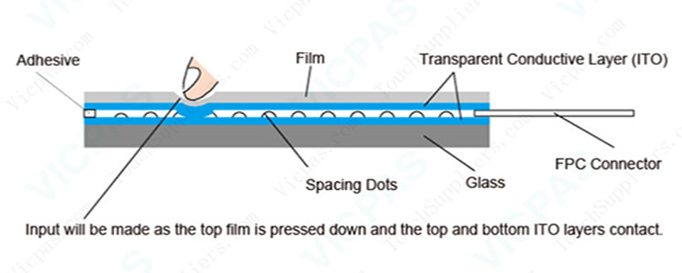
4wire and 5wire resistive touch screen is a two-layer structure, two materials (film or glass) with ITO are attached with a gap between them so that the ITO layers are facing each other. Touch input will be made as the top layer is pressed down and the two ITO layers contact. There are insulators called spacing dots between the top and bottom ITO layers. These spacing dots prevent unintended contacts (inputs) of the ITO layers when not pressed.

2. How to clean a touch screen?
Cleaning with a Microfiber Cloth
- Choose a microfiber cloth. This is ideal for cleaning a touchscreen. Some devices will have such a cloth included or perhaps you can borrow one you use on your sunglasses.
- Turn off the device before commencing to clean it. It is usually much easier to see where to clean when the device is switched off.
- Give the screen a once over by brushing it with the microfiber in small circles.This will remove the majority of simple imperfections.
- Only if truly needed, moisten a cotton cloth, even the corner of your cotton shirt, and repeat the small circular motions. It may actually be enough to just breathe over the screen and use that moisture to clean with.
- Brush again with the microfiber cloth to finish off. Don't over-rub though! And if there is any dampness left, just leave it to air dry.Do not put too much pressure on the screen when cleaning it.
- Wash the microfiber cloth.

3. Can I use a resistive single touch screen with mitten?
Of course, a resistive single touch screen can be used with mitten.

4. How long is the operation life of a resistive single touch screen from VICPAS?
12 million touches are guaranteed for a 4 wire touch screen.
37 million touches are guaranteed for a 5 wire touch screen.

5. If I need a resistive single touch screen whose specifications are tailored to my needs.
VICPAS can provide a resistive single touch screen customized to your requested specifications. Please contact us for more details.

6. How is your production management and quality control system?
VICPAS develops process - oriented QMS to identify and meet needs of customer requirement and expectation in an effective and efficient manner to achieve competitive advantage.
All our product process follows up ISO9001: income quality checking, in process quality checking, final product quality checking. The strict implementation of ISO9001 assures to provide error – free products to our customers.
We will show you these in our workshop during your visiting.
If you are interested in our products,please contact us for further information without hesitate.We will reply you as soon as we receive your inquiry.
VICPAS Looking forword to your cooperation.

